
ACTIVE LEARNING TEMPLATE: Growth and Development

STUDENT NAME

DEVELOPMENTAL STAGE INFANT REVIEW MODULE CHAPTER

EXPECTED GROWTH AND DEVELOPMENT


Physical | Cognitive | Psychological | Age- Appropriate
Physical | Cognitive | Development | Activities
Development | Development | Development | Activities

The new born will increase in weight after fifteen days. The first month weight gain is on average 170g and 2.5 cm (Malina, 2012).

Health promotion

The baby is developing abilities to think remember and learn at a very quick pace. The baby should be engaged in activities that support this development.
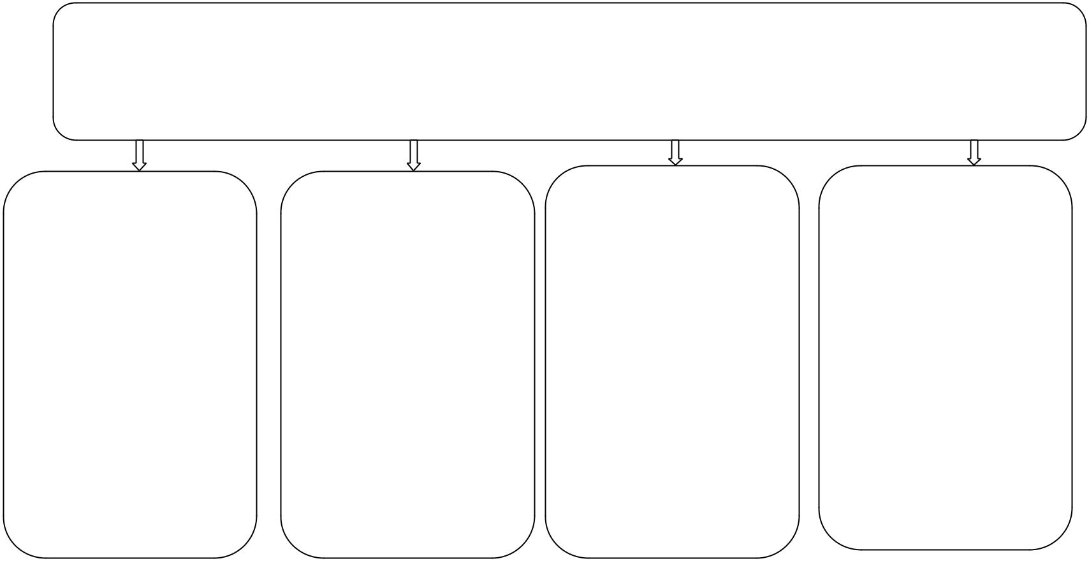

The baby first forms The activities that

of communication help in cognitive

are via sound and developments are

facial expressions. encouraged such as

The baby will cry to responding to the

signal uncomfortable sounds and singing

will smile to respond and dancing with the

to pleasure. Baby (Malina, 2012).

The issues alerting situations include constant fever, baby crying, diaper rush and high temperature among others. Most situations require clinical care.

Immunizations |  | Health Screening
The hepatitis B |  | Screening must be
should be |  | done very regularly
administered after |  | which should
birth .Hepatitis |  | concentrate on the
immune globulin |  | immunization,
Only for newborn |  | physical examination
with HBsAg-positive |  | and dietary and
mother, must be |  | stool/urine
given within 12 |  | assessment
hours of birth.

Nutrition

The baby is mainly kept on breast milk and suggested formula. The rules of hygiene are kept strictly and mothers are encouraged to carry the bay (Hills, 2007).

Injury Prevention

Infant should be checked constantly. Monitor the temperature of food being served to infants. When crawling lock all the exits and places that can lead to a fall.

ACTIVE LEARNING TEMPLATES THERAPEUTIC PROCEDURE A5

